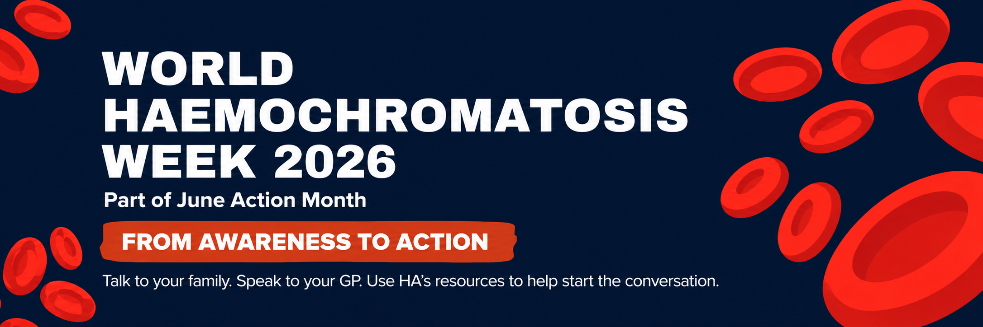
World Haemochromatosis Week 2026
MP letter template
[Your name]
[Your address/suburb]
[Email address]
[Date]
[MP name]
[Electorate office address/email]
Dear [MP name],
World Haemochromatosis Week: please help raise awareness
I am writing as one of your constituents to ask you to support World Haemochromatosis Week, 1-7 June 2026.
Haemochromatosis is one of Australia’s most common genetic conditions. It causes the body to absorb and store too much iron and can lead to serious health problems if it is not diagnosed and managed.
It also runs in families. When one person is diagnosed, close biological relatives may need to speak with their GP about whether testing is appropriate.
This World Haemochromatosis Week, Haemochromatosis Australia is encouraging people to move from awareness to action by talking to their family, speaking with their GP, using HA’s resources, joining the Australian Haemochromatosis Registry if eligible, donating blood if they can, and sharing the message.
I would be grateful if you could help raise awareness by sharing Haemochromatosis Australia’s campaign with your local community.
Campaign resources are available on our website.
https://haemochromatosis.org.au/whats-on/world-haemochromatosis-week.
Thank you for supporting better awareness, earlier diagnosis and stronger outcomes for people and families affected by haemochromatosis.
Yours sincerely,
[Your name]
[Your suburb/electorate]

