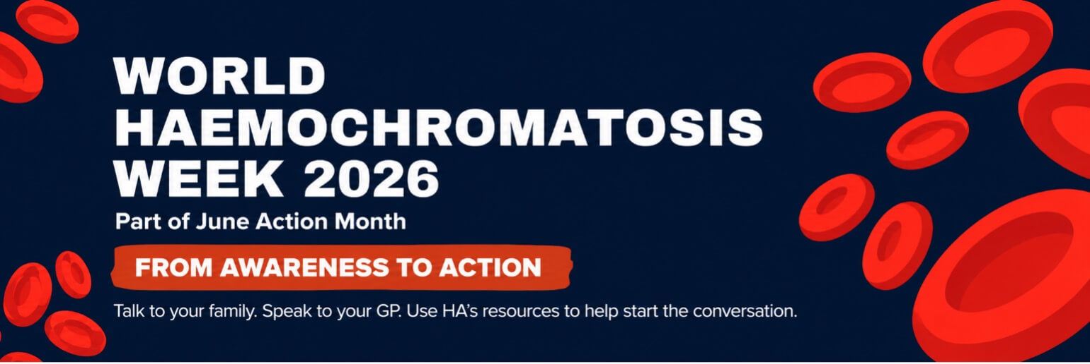

World Haemochromatosis Week 2026
Aligned organisation share pack

Purpose
World Haemochromatosis Week runs from 1-7 June 2026.
Haemochromatosis Australia is asking aligned organisations, health professionals, GP clinics, community health organisations, researchers, allied health groups and partner organisations to help share clear, practical information with their communities.
This year’s campaign platform is: From Awareness to Action.
The campaign encourages people to:
- Talk to their family.
- Speak to their GP.
- Use HA’s resources to help start the conversation.
- Join the Australian Haemochromatosis Registry if eligible.
- Donate blood if they can.
- Share the message.
Campaign page: https://haemochromatosis.org.au/whats-on/world-haemochromatosis-week/

Hashtags: #WHW2026 #beatoverload
HA channels: Facebook: www.facebook.com/Haemochromatosis | Instagram: @hamochromatosisaustralia | LinkedIn

Newsletter or website snippet for aligned organisations
World Haemochromatosis Week: 1-7 June 2026
World Haemochromatosis Week runs from 1-7 June 2026.
Haemochromatosis is one of Australia’s most common genetic conditions. It causes the body to absorb and store too much iron, which can lead to serious health problems if it is not diagnosed and managed.
It also runs in families. When one person is diagnosed, close biological relatives may need to speak with their GP about whether testing is appropriate.
This year, Haemochromatosis Australia is helping people move From Awareness to Action by encouraging families to talk, speak with their GP, use HA’s resources, join the Australian Haemochromatosis Registry if eligible, donate blood if they can, and share the message.
Find campaign resources at: https://haemochromatosis.org.au/whats-on/world-haemochromatosis-week/

For information and support, call the HA Info Line on 1300 019 028.

Share-ready social caption 1: general campaign
World Haemochromatosis Week runs from 1-7 June 2026.
Haemochromatosis is one of Australia’s most common genetic conditions. It causes the body to absorb and store too much iron, and it runs in families.
This June, Haemochromatosis Australia is helping people move from awareness to action.
Talk to your family.
Speak to your GP.
Use HA’s resources to help start the conversation.
Find out more:
https://haemochromatosis.org.au/whats-on/world-haemochromatosis-week/

#WHW2026 #beatoverload

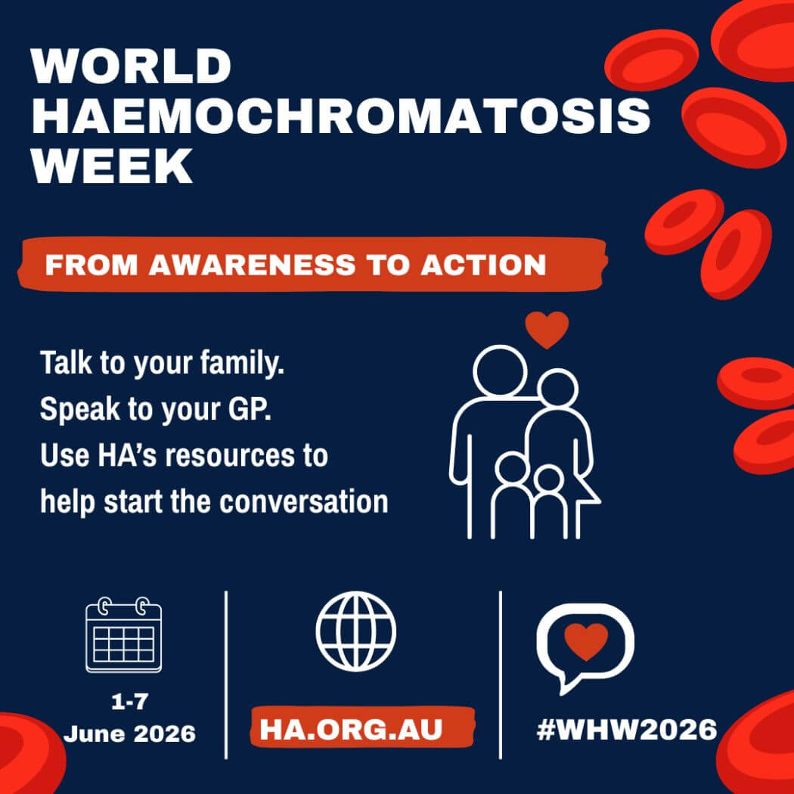

Share-ready social caption 2: family message
Haemochromatosis runs in families.
If haemochromatosis is in your family, it may be worth speaking with your GP about whether testing is appropriate for you.
Haemochromatosis Australia has resources to help families start the conversation, including a Family Letter and Practical Action Toolkit.
Find out more:
https://haemochromatosis.org.au/whats-on/world-haemochromatosis-week/

#WHW2026 #beatoverload

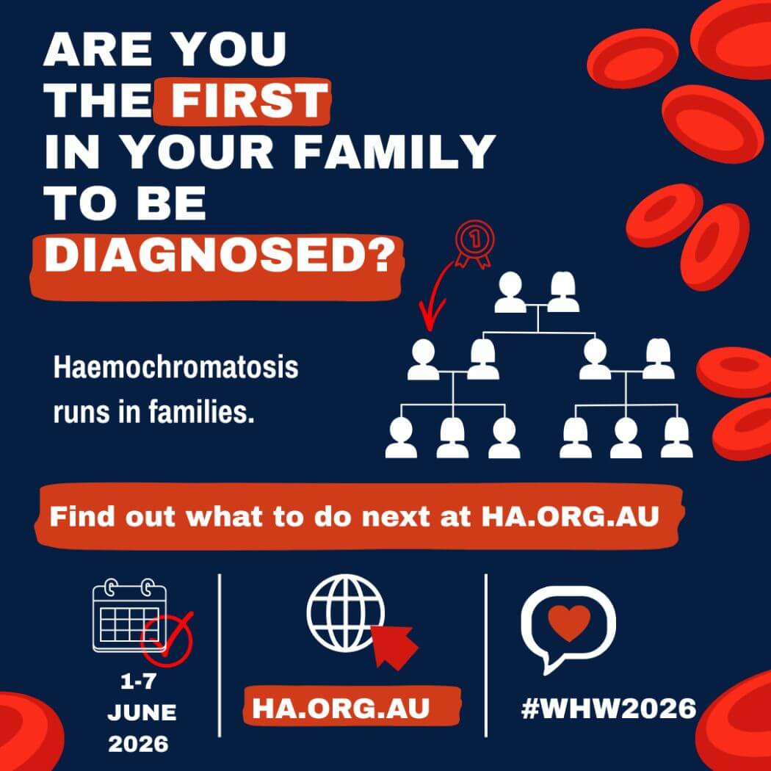

Share-ready social caption 3: GP/resource message
This World Haemochromatosis Week, Haemochromatosis Australia is encouraging people to use trusted resources to start informed conversations with their GP.
HA’s Family Letter and Practical Action Toolkit can help families understand what to ask and where to find support.
Explore the campaign resources:
https://haemochromatosis.org.au/whats-on/world-haemochromatosis-week/

#WHW2026 #beatoverload

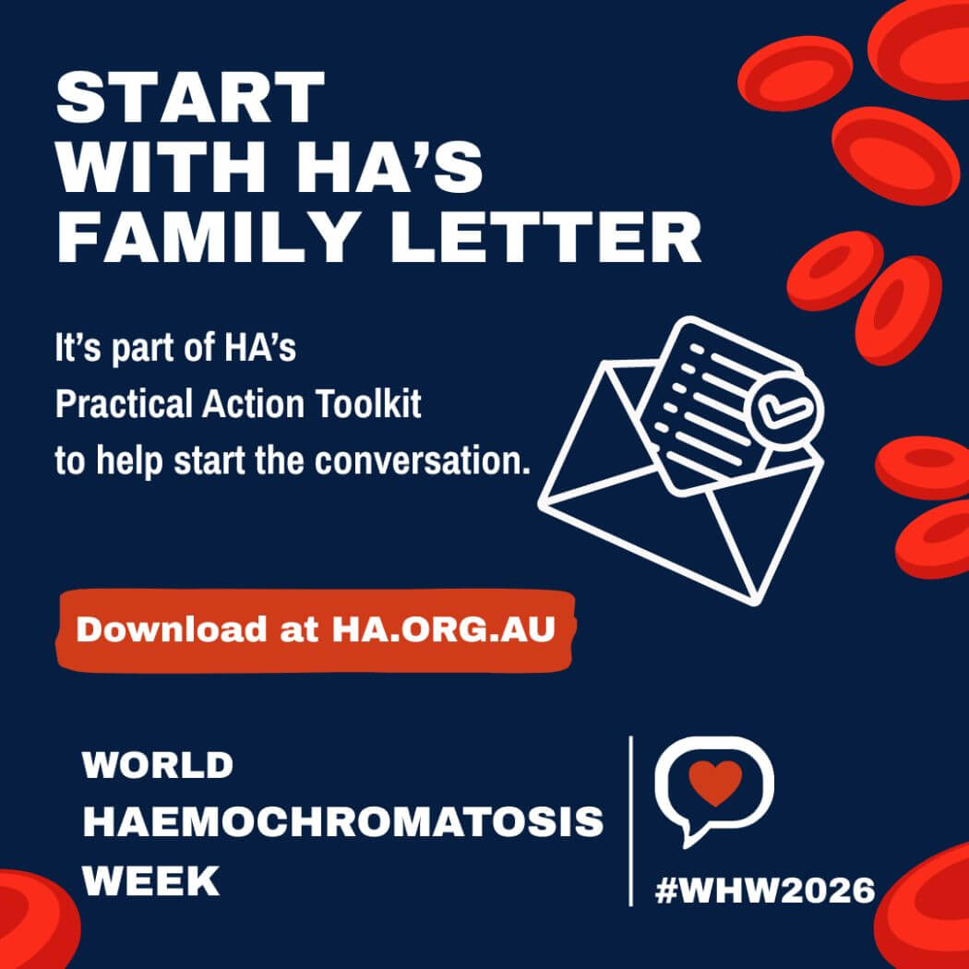

Share-ready social caption 4: Registry message
Help Haemochromatosis Australia reach 2,000 Registry participants.
The Australian Haemochromatosis Registry helps improve understanding of diagnosis, treatment access, health outcomes and patient experience.
People aged 18 and over with a confirmed diagnosis of haemochromatosis can join.
Find out more:
https://registry.ha.org.au

#WHW2026 #beatoverload
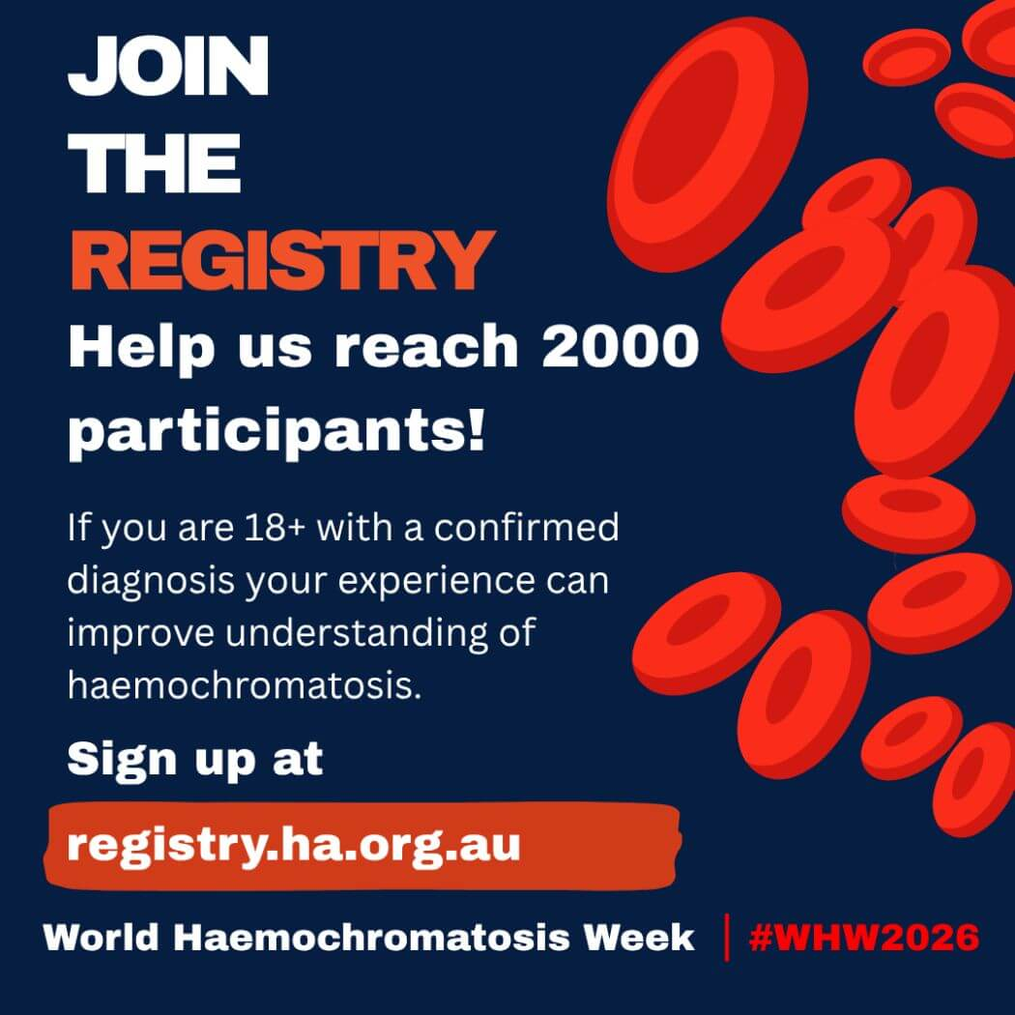

Share-ready social caption 5: support message
You are not alone.
If you or someone in your family is affected by haemochromatosis, Haemochromatosis Australia provides information, resources and support.
Call the HA Info Line on 1300 019 028 or visit:
https://haemochromatosis.org.au/whats-on/world-haemochromatosis-week/

#WHW2026 #beatoverload
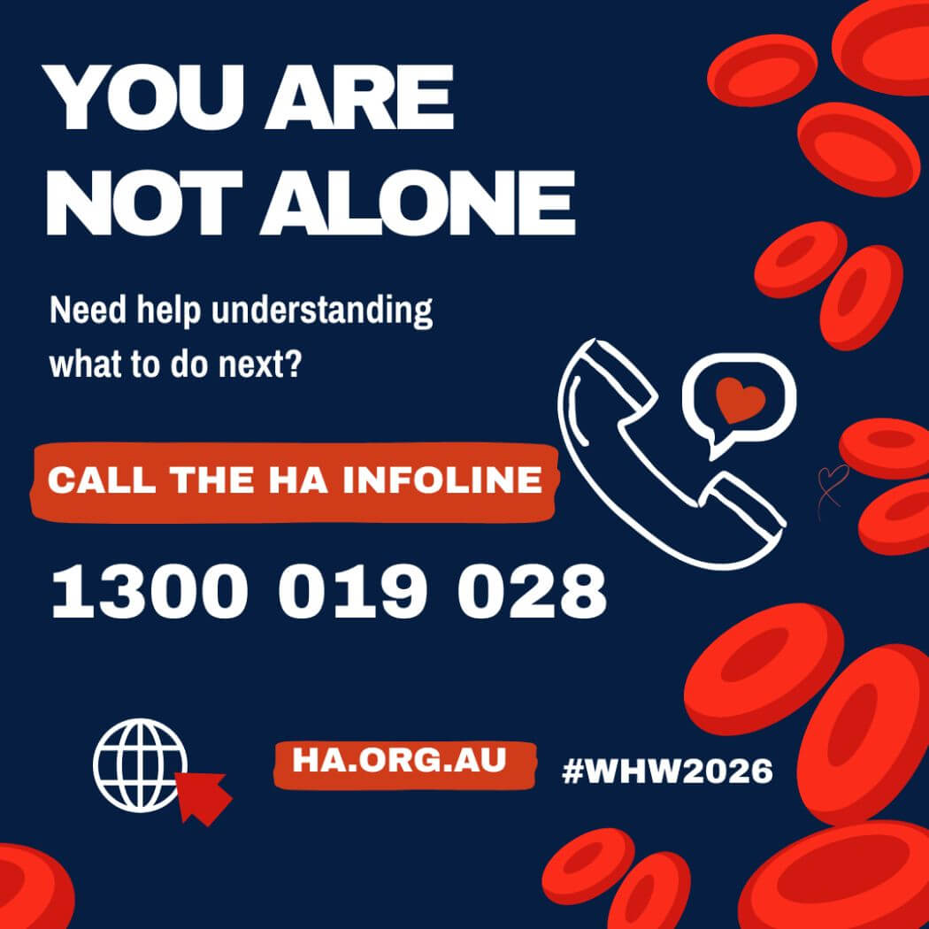

Share-ready social caption 6: donate/share message
This June, you can take action in the way that is right for you.
Donate blood if you can.
Share the message if you can’t.
Encourage one person to learn more.
Join the Registry if you are eligible.
World Haemochromatosis Week runs from 1-7 June.
Find out more:
https://haemochromatosis.org.au/whats-on/world-haemochromatosis-week/

#WHW2026 #beatoverload
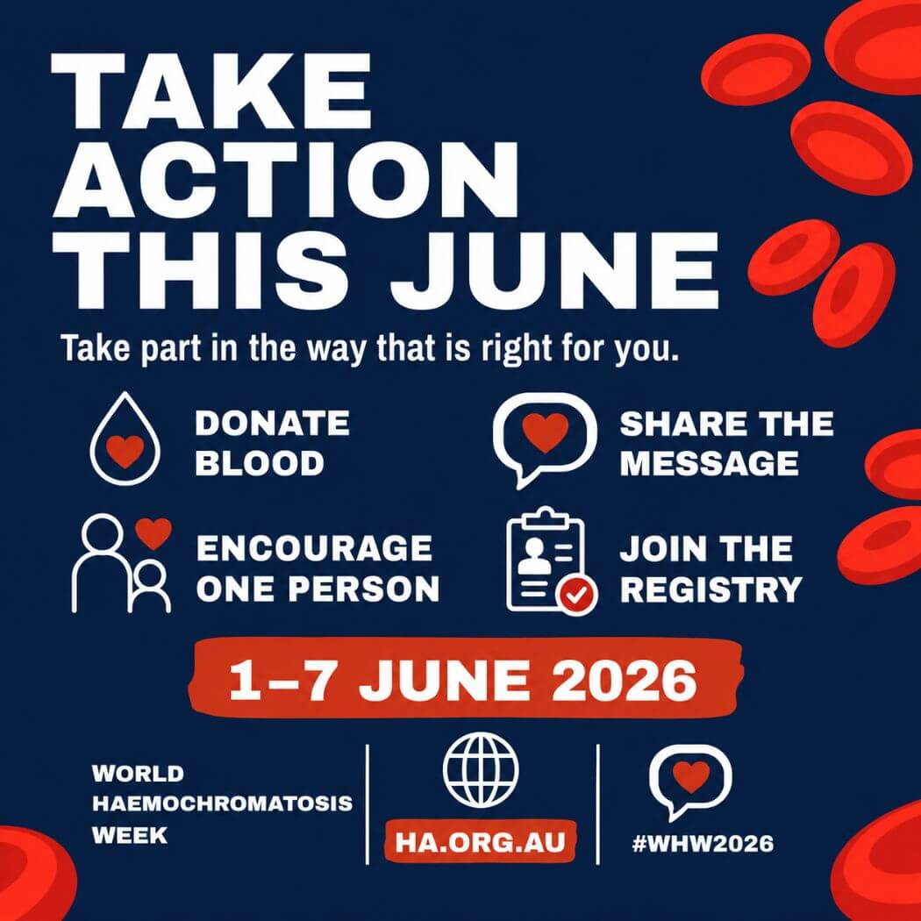

Thank you from Haemochromatosis Australia

Thank you for helping share World Haemochromatosis Week 2026.
Please feel welcome to use the supplied tiles and copy as provided, or adapt the captions slightly to suit your channel. We ask that you keep the campaign link, hashtags and references to Haemochromatosis Australia included where possible.
Campaign link: https://haemochromatosis.org.au/whats-on/world-haemochromatosis-week/

Hashtags: #WHW2026 #beatoverload
Info Line: 1300 019 028

